NOVAC Technology Solutions



Business Requirement Document

For

SGI Philippines – Motor & Non-Motor Products

Revision History

Version No. | Date | Reason For Changes | Author | Reviewer | Approver
Draft 132.1 | 18-Oct-2024 | Implementation of Policy preview pdf before policy generation | Arunkumar M | Nijanthan | Mr. Manoj Joseph
132.2 | 21-Oct-2024 | Required watermark in the preview policy schedule document | Arunkumar M | Nijanthan | Mr. Manoj Joseph
132.0 | 21-Oct-2024 | Baseline document of draft version 132.2 | Arunkumar M | Nijanthan | Mr. Manoj Joseph

Table of Contents
1. Introduction 4
1.1. Purpose 4
1.2. References 4
2. Functional Overview 4
2.1. Assumption and Dependencies 4
3. Interface Requirements 5
3.1. Internal Interfaces 5
3.1.1. Hardware Interface 5
3.1.2. Software Interface 5
3.1.3. Communication Interface 5
3.2. External Interfaces 5
3.2.1. Hardware Interface 5
3.2.2. Software Interface 5
3.2.3. Communication Interface 5
3.3. Operating Environment Requirement 5
3.3.1. Hardware Requirements 5
3.3.2. Software Requirements 5
3.3.3. Network Requirements 5
3.3.4. Operational scenarios 5
3.4. Non Functional Requirements (NFR) 6
3.4.1. Reliability 6
3.4.2. Performance 6
3.4.3. Security 6
3.4.4. Usability 6
3.4.5. Other Requirements 6
3.5. Open Issues 6
3.6. Acceptance Criteria 6
4. Appendix A 6

Introduction

Purpose
The purpose of this requirement is to implement an option to view the policy pdf before generation/issuance. This is applicable for all products.
  - Guidelines, circulars, instructions and directions released from time to time by Philippines Insurance council .

References

Functional Overview

Sl. No. | FIELD NAME | FIELD TYPE | INPUTS | VALIDATION
1 | Policy Preview | Button |  | 1. A new “Policy Preview” button will be added before the "Policy Generate" button in the user interface.  2. This will be enabled only if the proposal number is generated and installment created.  3.Upon clicking the button, sample Policy PDF will be downloaded without policy Number for user’s reference.  4.The downloaded policy should have a watermark as “DRAFT POLICY” in all the pages.

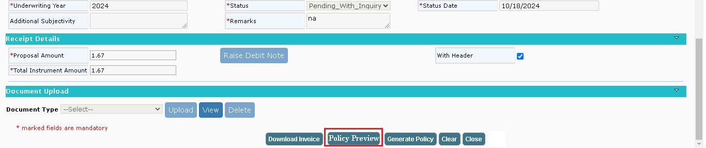

Assumption and Dependencies
<Not Applicable>

Interface Requirements

Internal Interfaces

Hardware Interface
<Not Applicable>

Software Interface
<Not Applicable>

Communication Interface
<Not Applicable>

External Interfaces

Hardware Interface
<Not Applicable>

Software Interface
<Not Applicable>

Communication Interface
<Not Applicable>

Operating Environment Requirement
<Not Applicable>

Hardware Requirements
<Not Applicable>

Software Requirements
<Not Applicable>

Network Requirements
<Not Applicable>

Operational scenarios
<Not Applicable>

Non Functional Requirements (NFR)

Reliability
<Not Applicable>

Performance
<Not Applicable>

Security
<Not Applicable>

Usability
<Not Applicable>

Other Requirements
<Not Applicable>

Open Issues
<Not Applicable>

Acceptance Criteria
- Functional testing will be executed by internal testing team, and the same will be delivered to client for UAT.

Appendix A
Not Applicable

